Cairo University  
Faculty of Computers and Information

**CS251**

**Software Engineering I**

**E _ Website**

Software Requirements Specifications

Team Leader

**Mohamed K Amer**

Month & Year

5 Nov 2016 at 23:59

Contents

Team 3

Document Purpose and Audience 3

Introduction 3

Software Purpose 3

Software Scope 3

Definitions, acronyms, and abbreviations 3

Requirements 4

Functional Requirements 4

Non Functional Requirements 4

System Models 4

Use Case Model 4

Use Case Tables 5

Ownership Report 10

Policy Regarding Plagiarism 10

# Team

|  |  |
| --- | --- |
| **ID** | Student Name |
| 20130194 | **Mohamed Khaled Mohamed Amer** |
| 20140071 | **Omnia Shawky Abdullah** |
| 20140118 | **Rasha Rabie El-Fauomy** |
| 20140209 | **Laila Barakat Mohamed** |

# Document Purpose and Audience

## This document is written by us to inform our audience about the components of our product, which can be Functional Requirements, Non Functional Requirements, Use Case Model, Use Case Tables, Flow of Events and also how our website can achieve the purpose that it has been developed for it.

It is intended to help designers and developers to develop the product and the testers to test it; also it is the basis for agreement and contract with our customers.

**Our audience will be:**

* **Developers**
* **Software Engineers**
* **Designers**
* **Programmers**
* **Users (Teachers, Students)**

# Introduction

## Software Purpose

The main goal of our software is creating an environment for learning for younger children to teach them how to deal with theories and sciences through simple games and features that teachers can develop these simple games with their educational goal.

Also teachers can teach students sciences and simple theories from a distance that may be hundreds or thousands of miles from the actual users.

The secondary goal is to combine the education with entertainment for children to attract their attention with a good method, this process called a courseware.

## Software Scope

This software is a website supported by any device that uses the internet.

It is designed for helping students to understand basic educational concepts while playing simple games, also teachers who use the website can manage the games by creating, adding, updating and removing games.

Any user can register an account on our software and use our features.

## Definitions, acronyms, and abbreviations

|  |  |
| --- | --- |
| **Definition** | **Description** |
| **Courseware** | Courseware is a term that combines the words 'course' with 'software'.  Its meaning originally was used to describe additional educational material intended as kits for teachers or trainers or as tutorials for students. |
| **DDoS Protection** | Denial of Service Attacks is a cyber-attack where the perpetrator seeks to make a machine or network resource unavailable. |

# Requirements

## Functional Requirements

* **Register to the system**
  + The system will allow users to create an account on it, in order to use its features according to the type of user.
  + The system will display the user types when the user registers to the system.
  + The system will have two types of users (Student, Teacher) and any of them can create an account with his name, email, password, additional attributes and other data that the system require.
  + The system will have different mechanisms to recover passwords that the user had forgotten, also will have a remember password function to save the password’s user on his browser.
  + The system will allow users to login with their accounts to the system.
  + The system will allow users to logout from their accounts on the system.
* **Searching process** 
  + Any user on the website can search for any game that he wants to play.
  + The system will have a user-friendly search bar.
  + When the user entered any game name in the search bar, the system will retrieve all games that have the name that the user entered it, and the system will view the result on website’s interface.
* **Play a game**
  + The system will be a website has many educational games are added by Teachers.
  + Any user can search for any game that he wants to play.
  + System will allow users to start playing any game.
  + System will allow users to stop playing any time that they want to give up playing.
  + After closing the game, the system will view the player’s score.
* **Create a game**
  + The system will allow teachers to create any game on the website, also allow them to add it on the database with game name and educational purpose.
  + The game will be added in the games list by the system and will be free to play any time.
* **Modify a game**
  + The system will allow teachers to modify a game that they had created it before.
  + The teachers will be able to update or remove a game that they own from the database of the website.
* **Evaluate process**
  + The system will allow users to evaluate any game by adding a comment or rate it.
  + The system will have a user-friendly evaluation interface.
  + After evaluating process, the system will display total game evaluations.

## Non Functional Requirements

|  |  |
| --- | --- |
|  | **Details** |
| **Performance** | 1- All queries will return a response in < 2 seconds.  2- The loading time for any game on the system must be smaller than 10 seconds.  3- Website pages interface will response in <5 seconds. |
| **Usability** | 1- The system will have a user-friendly interface to be familiar to younger children and easy to survey.  2- The system will have a familiar guideline tutorial to help users know how to deal with our website. |
| **Security** | 1- The system will automatically log out all users after a period of inactivity.  2- The system will not leave any cookies on the user’s device containing any of the user’s confidential information.  3- There will be DDoS Protection. |
| **Scalability** | 1- The system will allow more than 4,000 users operating on it at the same time. |
| **Maintainability** | 1- Make future maintenance easier.  2- Deal with a changed environment.  3- Maximize a product's useful life.  4- Prevent unexpected breakdowns.  5- Correct defects or their cause. |

# 

# System Models

## Use Case Model

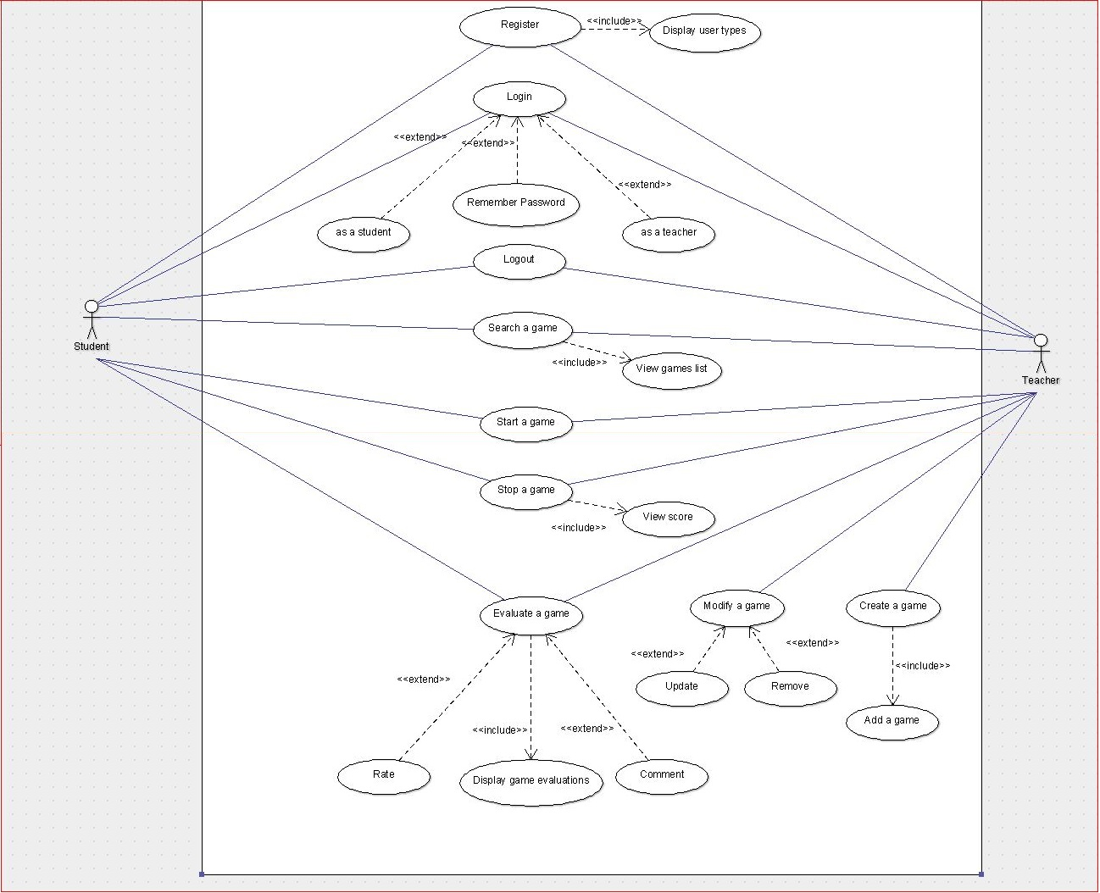

## Use Case Tables

|  |  |  |
| --- | --- | --- |
| **Use Case ID** | **1** | |
| **Use Case Name** | **Register** | |
| **Actors** | **Student, Teacher** | |
| **Pre-Conditions** | **\* An actor has no account on our website.**  **\* He wants to create a new account on our software.** | |
| **Post-Conditions** | **\* An actor has an account.**  **\* He can login and use our features.** | |
| **Flow of events** | **User Action** | **System Action** |
| **1- User wants to make a new account.**  **2- User enters his account data to register.** |  |
|  | **3- System verifies user data.**  **4- System sends a confirmation message.** |
| **5- User can login now.** |  |
| **Exceptions** | **User Action** | **System Action** |
| **1- User enters his account data.** |  |
|  | **2- Data is invalid.**  **3- System sends an error message.** |
| **Includes** | **Display user types** | |
| **Notes and Issues** |  | |

|  |  |  |
| --- | --- | --- |
| **Use Case ID** | **2** | |
| **Use Case Name** | **Login** | |
| **Actors** | **Student, Teacher** | |
| **Pre-Conditions** | **\* An actor has an account on our website.**  **\* He wants to login to his account.** | |
| **Post-Conditions** | **\* A student can search, play and Evaluate a game.**  **\* A teacher can create, modify, check the Evaluation and play a game.** | |
| **Flow of events** | **User Action** | **System Action** |
| **1- User enters his account data to login.** |  |
|  | **2- System verifies user data account.**  **3- System accepts and submits.** |
| **4- User can use website features now.** |  |
| **Exceptions** | **User Action** | **System Action** |
| **1- User enters his account data to login.** |  |
|  | **2- Data is invalid.**  **3- System sends an error message.** |
| **Includes** |  | |
| **Notes and Issues** |  | |

|  |  |  |
| --- | --- | --- |
| **Use Case ID** | **3** | |
| **Use Case Name** | **Logout** | |
| **Actors** | **Student, Teacher** | |
| **Pre-Conditions** | **\* A user had already logged in the website.**  **\* A user wants to logout.** | |
| **Post-Conditions** | **\* The user logout of the website.** | |
| **Flow of events** | **User Action** | **System Action** |
| **1- User wants to logout of the website.** |  |
|  | **2- System terminates the login session.** |
| **Exceptions** | **User Action** | **System Action** |
|  |  |
|  |  |
| **Includes** |  | |
| **Notes and Issues** |  | |

|  |  |  |
| --- | --- | --- |
| **Use Case ID** | **4** | |
| **Use Case Name** | **Search a game** | |
| **Actors** | **Student, Teacher** | |
| **Pre-Conditions** | **\* A user login to his account on the website.**  **\* He wants to play a game.**  **\* He searches for this game to play.** | |
| **Post-Conditions** | **\* Games list appears on the website interface.** | |
| **Flow of events** | **User Action** | **System Action** |
| **1- User searches for a game in the search bar.** |  |
|  | **2- System views the searching result.** |
| **3- User selects the game that he wants to play.** |  |
| **Exceptions** | **User Action** | **System Action** |
| **1- User enters invalid name or a game name that does not exist.** |  |
|  | **2- System sends a no result message.** |
| **Includes** | **View games list** | |
| **Notes and Issues** |  | |

|  |  |  |
| --- | --- | --- |
| **Use Case ID** | **5** | |
| **Use Case Name** | **Start a game** | |
| **Actors** | **Student, Teacher** | |
| **Pre-Conditions** | **\* A user searches for a game that he wants to play.**  **\* Games list appears on the website interface.**  **\* User selects the game that he wants to play.** | |
| **Post-Conditions** | **\* Game starts and its interface appears on the website view screen.** | |
| **Flow of events** | **User Action** | **System Action** |
| **1- User wants to play a game.**  **2- User searches for a game in the search bar.** |  |
|  | **3- System views the searching result.** |
| **4- User selects the game that he wants to play.**  **5- User clicks on the starting button.** |  |
|  | **6- System executes game code.** |
| **7- User plays the game.** |  |
| **Exceptions** | **User Action** | **System Action** |
| **1- User chooses a game that is not working well or chooses a game in the time that a game is still working on the system.** |  |
|  | **2- System sends an error message.** |
| **Includes** |  | |
| **Notes and Issues** |  | |

|  |  |  |
| --- | --- | --- |
| **Use Case ID** | **6** | |
| **Use Case Name** | **Stop a game** | |
| **Actors** | **Student, Teacher** | |
| **Pre-Conditions** | **\* A user is playing a game.**  **\* He wants to stop the game.** | |
| **Post-Conditions** | **\* Game stops working and the user can play another game.** | |
| **Flow of events** | **User Action** | **System Action** |
| **1- User is playing a game.**  **2- User wants to stop the game.**  **3- User clicks on the stopping button.** |  |
|  | **4- System saves player’s score**  **5- System views player’s score**  **6- System terminates the process.**  **7- System sends a confirmation message.** |
| **Exceptions** | **User Action** | **System Action** |
|  |  |
| **Includes** | **View score** | |
| **Notes and Issues** |  | |

|  |  |  |
| --- | --- | --- |
| **Use Case ID** | **7** | |
| **Use Case Name** | **Evaluate a game** | |
| **Actors** | **Student, Teacher** | |
| **Pre-Conditions** | **\* A user played a game.**  **\* He wants to evaluate it.** | |
| **Post-Conditions** | **\* The evaluation is registered to the system.**  **\* The owner of the game decides to update or remove the game according to the evaluation form.** | |
| **Flow of events** | **User Action** | **System Action** |
| **1- User ends the game.**  **2- User wants to evaluate the game.**  **3- User rates or makes a comment on the game.** |  |
|  | **4- System saves the evaluation result on the database.** |
| **Exceptions** | **User Action** | **System Action** |
|  |  |
| **Includes** | **Display game evaluations** | |
| **Notes and Issues** | **There are no Exceptions in this function because it operates without any conflicts on the database.** | |

|  |  |  |
| --- | --- | --- |
| **Use Case ID** | **8** | |
| **Use Case Name** | **Create a game** | |
| **Actors** | **Teacher** | |
| **Pre-Conditions** | **\* A teacher has an account on our website.**  **\* A teacher wants to create a game.** | |
| **Post-Conditions** | **\* A teacher can Add a game that he has already created it.** | |
| **Flow of events** | **User Action** | **System Action** |
| **1- Teacher login to the website.**  **2- Teacher analyzes, design, implement and test a game.**  **3- Teacher adds the game to the website.** |  |
|  | **4- System adds the game into the games list on the database of the website.**  **5- System sends a confirmation message.** |
| **Exceptions** | **User Action** | **System Action** |
| **1- Teacher creates a game and tries to add it.** |  |
|  | **2- System finds out that the new game name is similar to an old game name that exists on the database.**  **3- System sends an error message.** |
| **Includes** | **Add a game** | |
| **Notes and Issues** |  | |

|  |  |  |
| --- | --- | --- |
| **Use Case ID** | **9** | |
| **Use Case Name** | **Modify a game** | |
| **Actors** | **Teacher** | |
| **Pre-Conditions** | **\* A teacher has an account on our website.**  **\* A teacher wants to modify a game that exists on the database.** | |
| **Post-Conditions** | **\* The game is modified and changes are saved to the database.** | |
| **Flow of events** | **User Action** | **System Action** |
| **1- Teacher login to the website.**  **2- Teacher wants to modify a game.**  **3- Teacher clicks on the modification button.** |  |
|  | **4- System executes the modification function and views its interface on the website screen view.** |
| **5- Teacher modifies the game.**  **6- Teacher clicks on the saving button.** |  |
|  | **6- System saves the modification on the database.**  **7- System sends a confirmation message.** |
| **Exceptions** | **User Action** | **System Action** |
| **1- Teacher tries to modify a game that he is operating it right now and its session is not closed yet.** |  |
|  | **2- System sends an error message.** |
| **Includes** |  | |
| **Notes and Issues** |  | |

# Ownership Report

|  |  |
| --- | --- |
| ***Item*** | ***Owners*** |
| *All* | *Mohamed K Amer* |
| *All* | *Omnia Shawky Abdullah* |
| *All* | *Laila Barakat Mohamed* |
| *All* | *Raja Rabie El-Fauomy* |

# 

# Policy Regarding Plagiarism

**Students have collective ownership and responsibility of their project. Any violation of academic honesty will have severe consequences and punishment for ALL team members.**

1. تشجع الكلية على مناقشة الأفكار و تبادل المعلومات و مناقشات الطلاب حيث يعتبر هذا جوهريا لعملية تعليمية سليمة
2. ساعد زملاءك على قدر ما تستطيع و حل لهم مشاكلهم فى الكود و لكن تبادل الحلول غير مقبول و يعتبر غشا.
3. أى حل يتشابه مع أى حل آخر بدرجة تقطع بأنهما منقولان من نفس المصدر سيعتبر أن صاحبيهما قد قاما بالغش.
4. قد توجد على النت برامج مشابهة لما نكتبه هنا أى نسخ من على النت يعتبر غشا يحاسب عليه صاحبه.
5. إذا لم تكن متأكدا أن فعلا ما يعد غشا فلتسأل المعيد أو أستاذ المادة.
6. فى حالة ثبوت الغش سيأخذ الطالب سالب درجة المسألة ، و فى حالة تكرار الغش سيرسب الطالب فى المقرر.